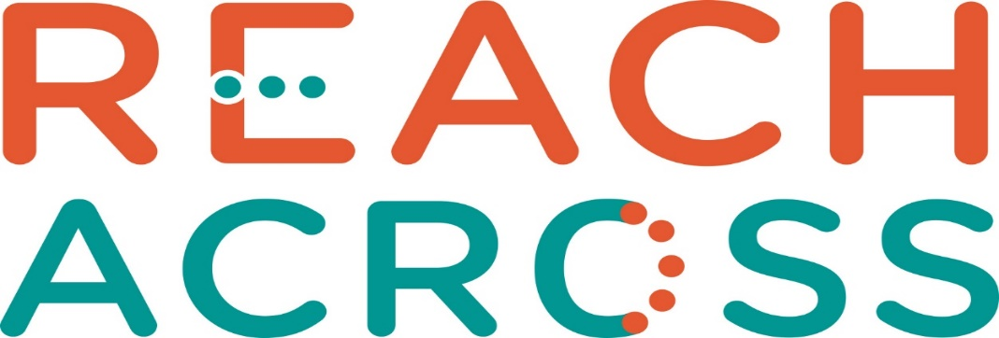

Annual General Meeting
Sunday 24th April 2022
11:00 – 13:00
Reach Across Hall
Guthrie Port, Arbroath

ALL WELCOME
Light Lunch will be available at close of A.G.M.

Enriching Lives : Enhancing Minds
Charity Number SC046240

